TOWN of PORTER
3265 Creek Road ♦Youngstown, New York 14174 ♦(716)745-3730, ext. 7♦ fax(716) 745-9022♦
Code Enforcement office ♦ p.jeffery@townofporter.net ♦ mobile(716) 531-6431

Permanent Home Generator Requirements

The following information is intended to assist the homeowner in having a permanent generator installed in a safe and ordinance compliant manner.

►A permit is required. (which can be downloaded here: https://www.townofporter.net/sites/g/files/vyhlif1101/f/uploads/building_permit_application-f_v04-f.pdf)
- The permit may be obtained by either the property owner or the contractor for the property owner.
- The contractor must have proof of valid NYS Worker’s Compensation & NYS Disability.
- When the homeowner is the contractor, they must have a “Certificate of Attestation of Exemption (CE-200)” submitted with their Building Permit Application Residential; Use the following link for procedure to acquire a CE-200 -https://www.townofporter.net/sites/g/files/vyhlif1101/f/uploads/homeowner-ce-200-exemption_guide.pdf
- The permittee Fee will be as set by the Town Board - “Fees: Building/Zoning/Planning” - annual schedule.
- Proposed location on the lot must be indicated on the survey copy.
- A copy of the survey of the property is needed so that it can be determined that the proposed location complies with the following:
- The Local Zoning Ordinance-The NYS Building & Fire Codes
- National Fire Protection Association Standard NFPA37
- The Manufacturers installation instructions November 2015

►A copy of the Manufactures installation Instructions, Generator manufacture and Model must be Submitted with the Permit application.

►The Generator location is very important to minimize Fire and Exhaust gas hazards. Generator shall be considered an Accessory structure and the respective Town Codes for Accessory Structures are applicable.

►The Code of the Town of Porter regulates Accessory Structures – A Generator is deemed an Accessory Structure. The following is thereby required:
Zoning Regulation: § 200-25 Accessory uses or structures;
Customary accessory uses and structures other than those mentioned elsewhere in this chapter may be permitted, provided the following:
A. No accessory structure may be built without a principal or primary structure on the lot.
B. All detached accessory structures shall be set back behind the front line of the principal structure.
(1) For corner lots, the front line of the principal building shall be determined along both street frontages regardless of orientation of the structure.
(2) For lots adjacent to the lake, the front building line shall be determined by the Zoning/Code Enforcement Officer based on the orientation of the dwelling. In some cases, and upon approval of the Zoning/Code Enforcement Officer, accessory structures may be placed in either or both yards, depending on the type of structure or use. However, no accessory structure shall obstruct the view of the lake.
C. Accessory structures (Generators), 10 feet or less in height and wholly within the rear yard, shall be located a minimum of five feet from any side or rear lot line; otherwise, the setbacks of the district shall apply.
D. Accessory structures shall be separated from the primary structure a minimum of 10 feet. An Exception is a Generator. Generators may be installed per the Manufacture’s Installation Instructions and must be rated by the manufacture for the installed proximity to a Dwelling or Primary Structure. See additional Location requirements herein.
E. Except for agricultural uses, the accessory structure shall not be larger than the primary structure in square footage.
F. The accessory use or structure is determined by the Zoning/Code Enforcement Officer to have no detrimental effect upon the health, safety and general welfare of the surrounding neighborhood and the community as a whole.
►When installing a “Third party Testing Agency” approved Generators must have a minimum of 18 inches clearance from a structure or other combustible materials on all sides. Non-Third-party Testing Agency approved Generators must have 5 feet clearance on all sides. All Generators must have 5 feet overhead clearance. (As measured from the Generator enclosure)
►The Generator must be a minimum of 5 feet from any opening in the Wall, Operable window, Vents, Intakes, and or exhaust.
►All Electrical panels (Distribution Panel) must have visible warning labels/tags located on the outside of said panel door(s).
►The Generator must be located so the exhaust gases will not collect adjacent to, enter, or be drawn into an occupied building. Attention to wind and Air Currents at the location, and distance to windows or other building openings must be considered.
►The Generator must not be located over buried utility services.
►Generator units must be installed level and not where water may accumulate/pond.
►Generator units must not block access to other utility equipment or components thereof.
►Smoke & CO² detectors must be located and installed, as part of the Generator installation project, to comply with the currently adopted Building/Fire Code.

►Inspections are Required

- Once the Generator unit is installed, all interior and Exterior electrical work must be inspected by a Town approved, third party, Electrical Inspector. When Electrical is found to comply, it must be inspected by the Town of Porter Code Enforcement Officer, to determine compliance with all applicable requirements.
- After required final inspection (final inspections by both agencies), a Certificate of Compliance must be issued by the Town of Porter prior to use of the Generator.
Typical Installation diagrams:
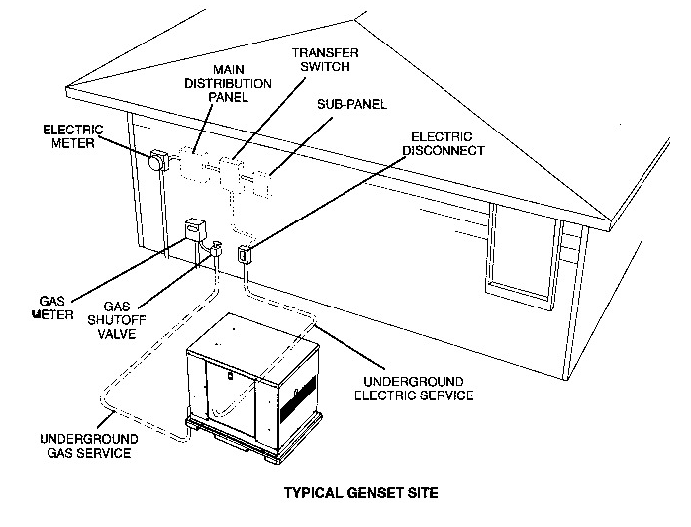
GenSets that are housed in weather-protective enclosures are designed for installation out-of-doors. Typically, a cement pad is placed in a suitable location, out of sight but with easy access for maintenance and fueling. The generator is secured to the pad. Choose a site close to the electric service and fuel supply lines (natural gas, propane, or diesel). The image above shows a typical natural gas installation. The main distribution panel, transfer switch and sub-panels are inside the building in this example, but sometimes the distribution panel, sub-panels and transfer switch are outside. You should make sure that 110v power is available at the generator for battery charging and or servicing.
The GenSet must be a minimum of 3 ft from combustible material (NFPA 37). Leave at least 3 ft (or more if specified on the housing and or manufactures instructions for your particular unit) all around the GenSet enclosure for access to the inside (NEC Art. 110-26a, Art. 110-26b). The GenSet must be at least 5 ft from any opening (window, door, vent, etc.) in a wall, and the exhaust must not be able to accumulate in any occupied area. See figure above. Electrical and Plumbing/Gas piping shall comply with the currently adopted Building Codes.

